**Core Java Index Version 2.0**

|  |  |
| --- | --- |
| **Table of Contents** | **Page No** |
| **Different Type’s of Language’s** |  |
| 1. **Collections framework** |
|  |
|  |
|  |  |
|  |
|  |
|  |
|  |  |

1. **Collections Framework**
2. **Collections:**A group of individual objects that are represented as single unit is known as a java collection of objects
3. Java collections are used to store the data and manipulate the data like sorting,searching ..etc
4. Through this collections we can perform all the operations on data like searching,sorting,insertion,manipulation and deletion of elements
5. In Java collections framework is introduced in JDK 1.2,which holds all the java collections interfaces and classes in it
6. Collections framework provides many interfaces (Set,List,Queue,Deque) and classes(ArrayList,LinkedList,Vector,Stack,HashSet,LinkedHashSet,TreeSet…etc).
7. In java,They are two main root interfaces of java collections classes
   1. java.util.Collection
   2. java.util.Map

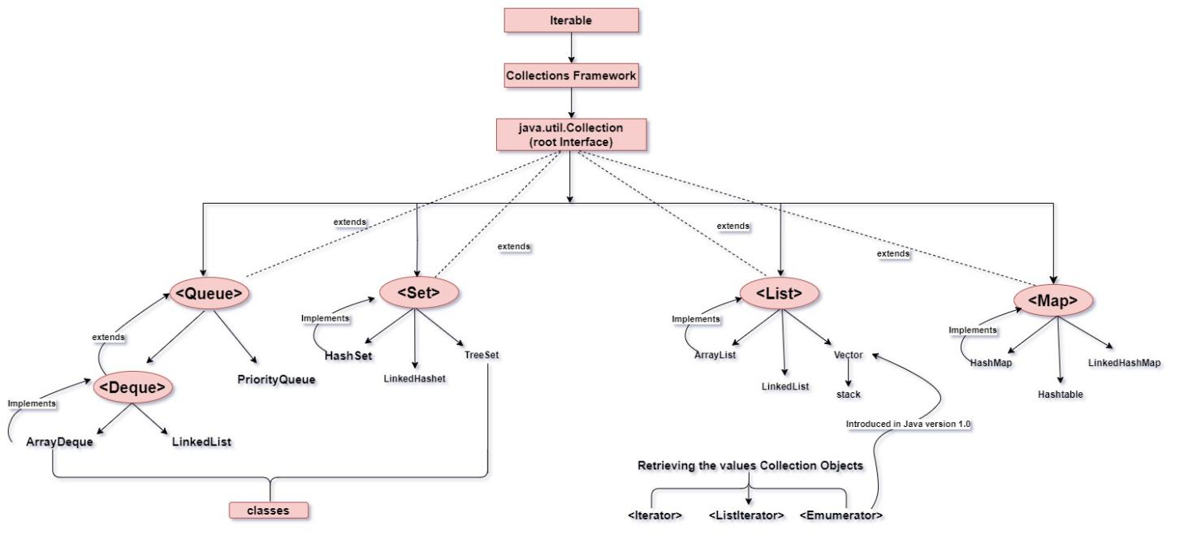

1. Retrieving the values from the collection objects is done in four ways
   1. **Iterator:-**The Iterator is used to iterate through the collection objects
   2. **ListIterator:-**The ListIterator is used to iterator from middle and through ListIterator we can travel front and back I,e we can move forward and previous(backward) from the particular position of the element
   3. **Enumeration:-**Enumeration in collection framework is used with vector
   4. **for each:-**for each is an advanced loop which is used to iterate through the collection objects in java

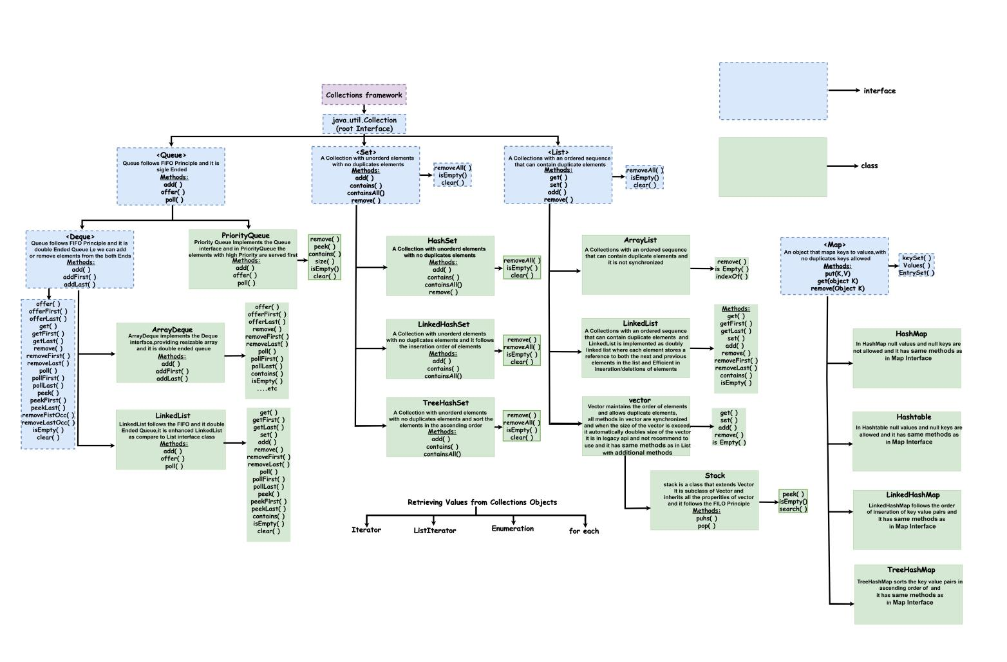

1. **In Collections Framework the the size of the ArrayList is Dynamic**
2. **It can store different Data types values**
3. **It has methods like add(),size()..etc**
4. **Vectors are legacy API and note recommend to use it is introduced in version 0**

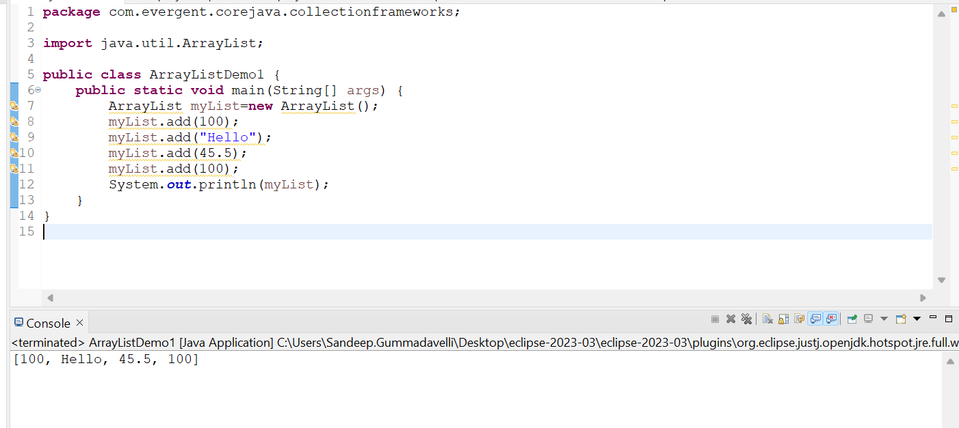

**Program:**ArrayListDemo1

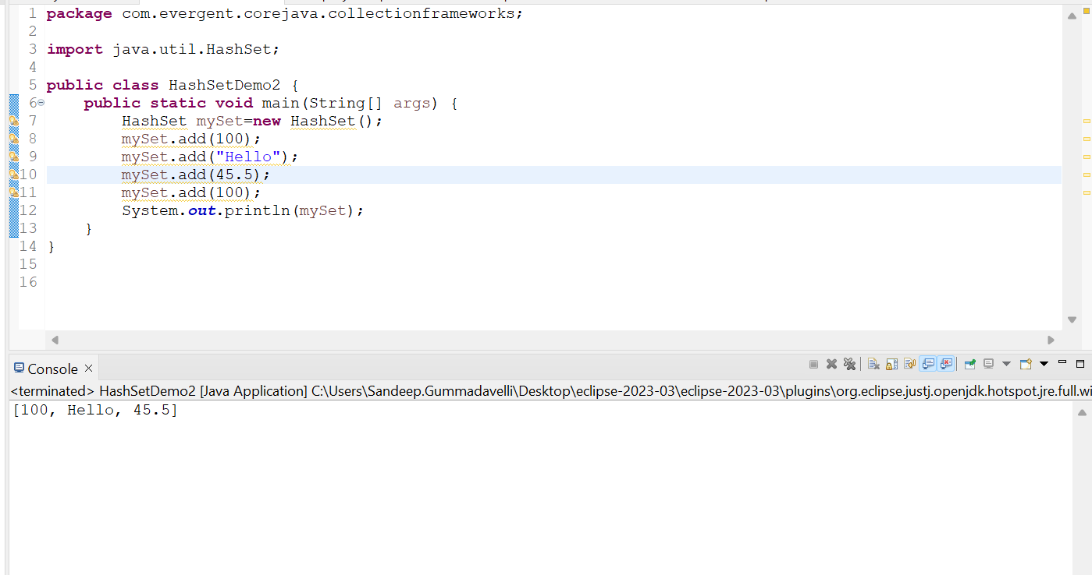

**Program:**HashSetDemo2

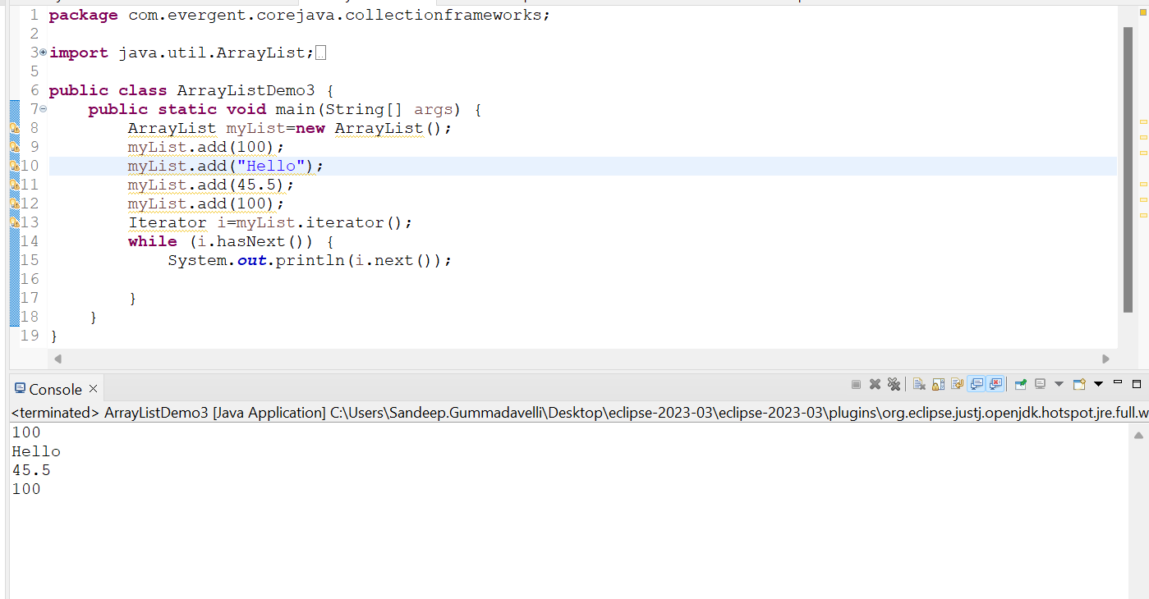

**Program:**ArrayListDemo3 Using **Iterator**

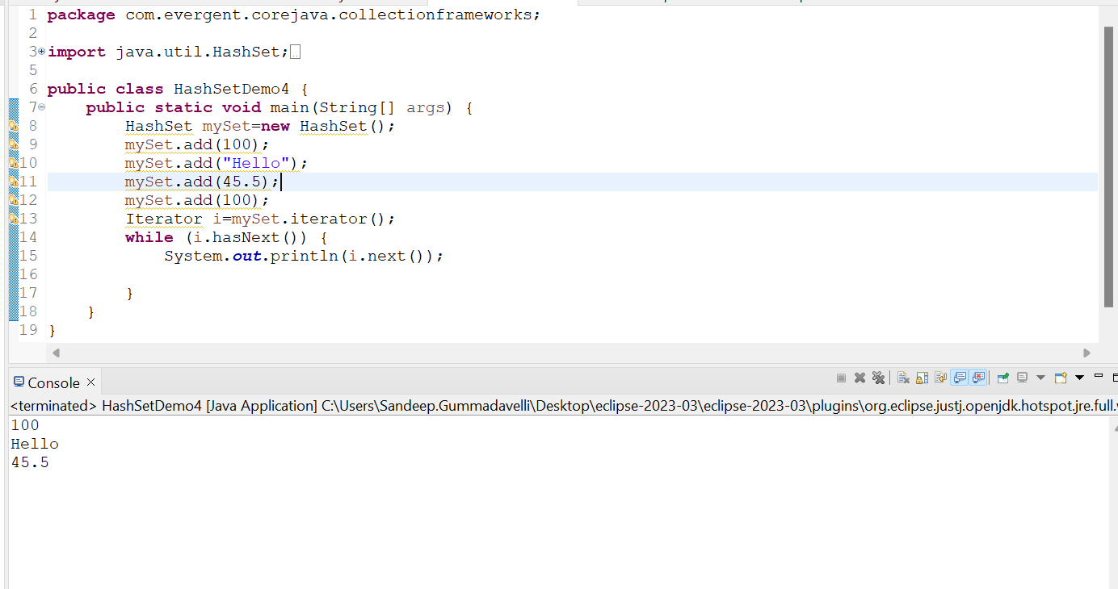

**Program:**HashSetDemo4 Using **Iterator**

1. **Wrapper Classes:** JDK 1.44 Doesn’t support primitive Data types it only supports objects

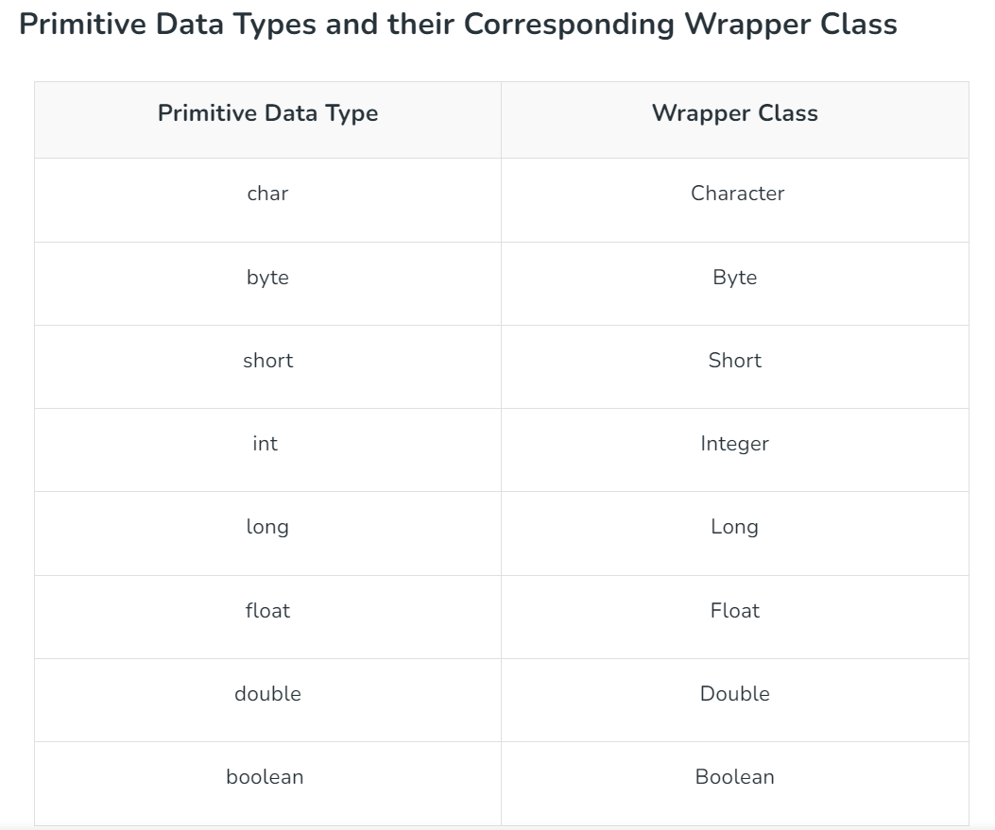

1. **AutoBoxing:**The Automatic conversion of primitive data types to the object o their corresponding Wrapper Classes is known as AutoBoxing

**Example: int to Integer**

**float to Float**

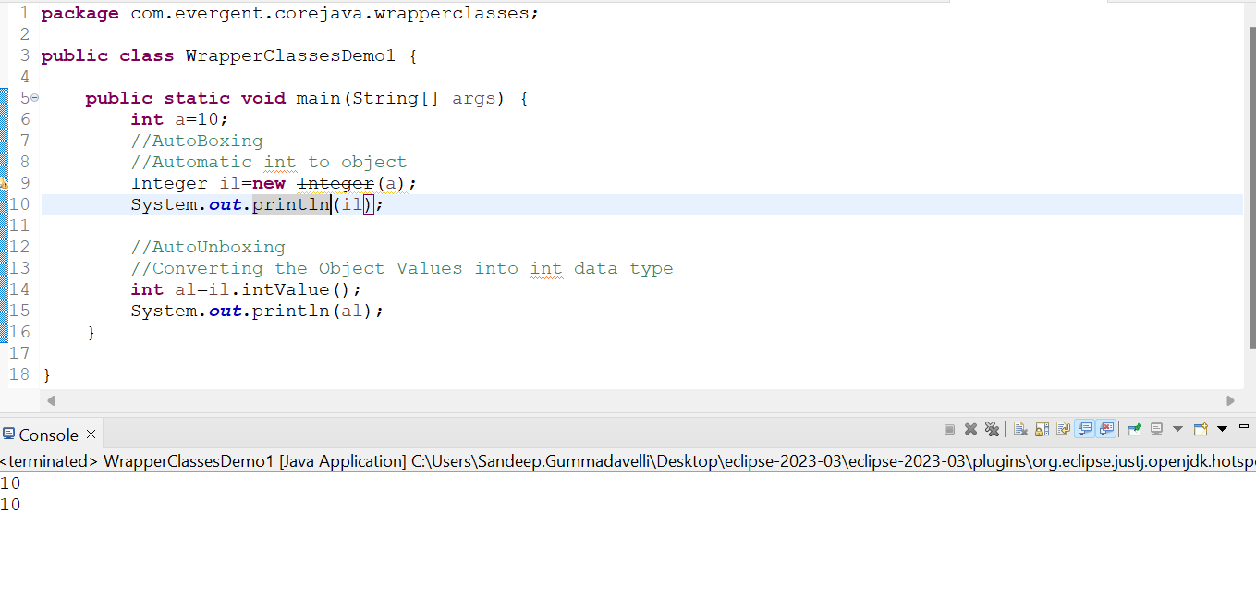

**Program:**WrapperClassesDemo1 AutoBoxing

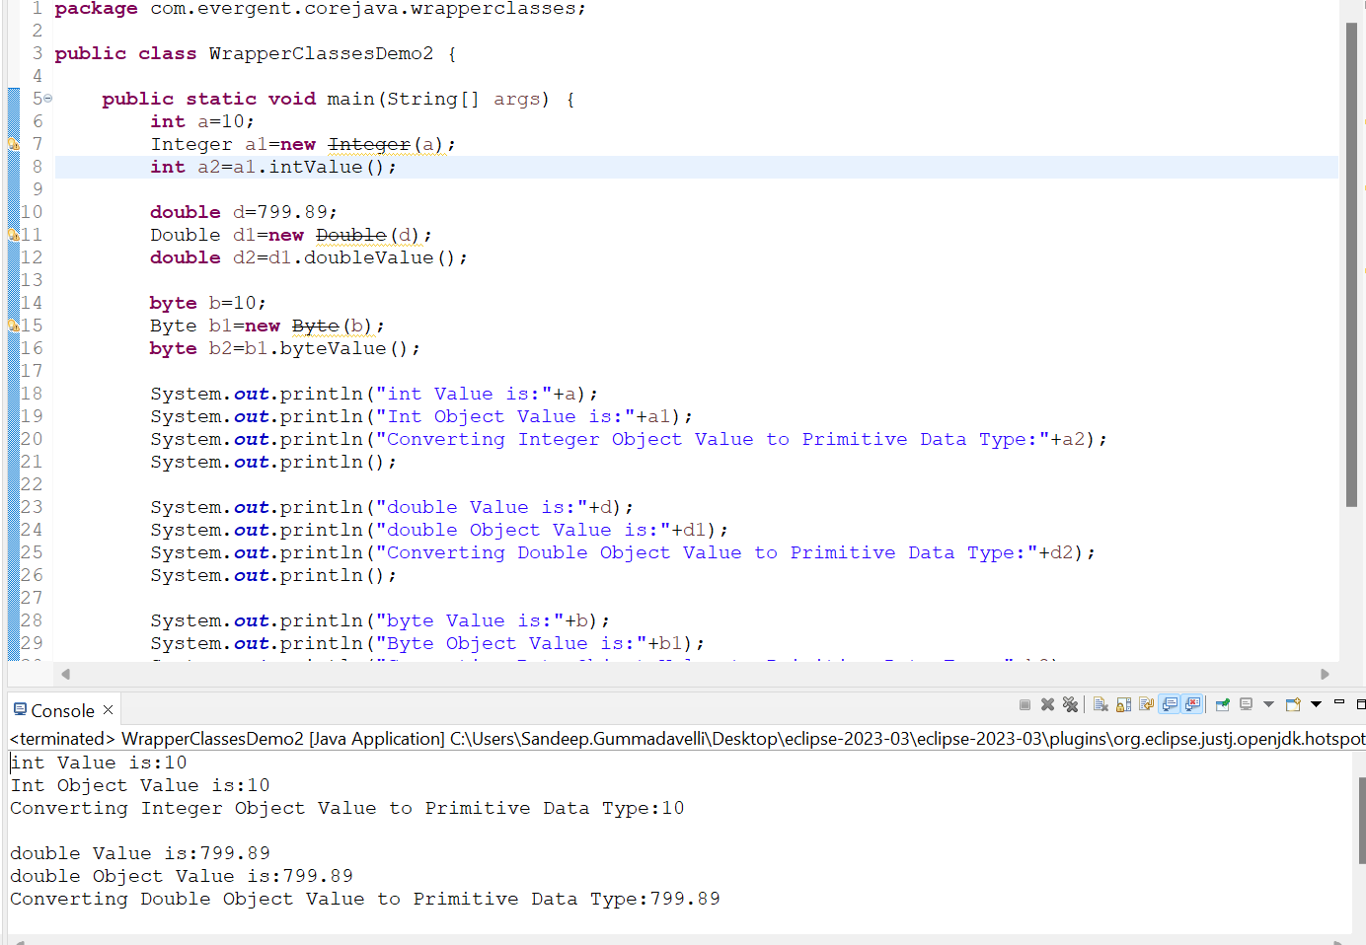

**Program:**WrapperClassesDemo2 AutoBoxing and Unboxing

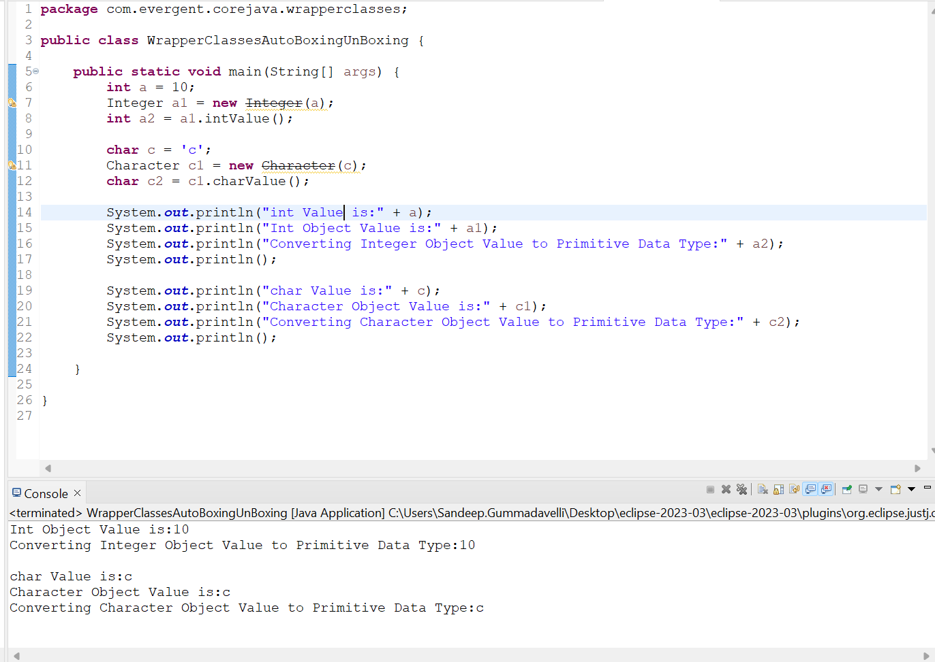

**Program:**WrapperClasses AutoBoxing and Unboxing3

1. **AutoUnBoxing:**It is just the reverse process of autoboxing. Automatically converting an object of a wrapper class to its corresponding primitive type is known as unboxing.

**Example: Integer to int**

**Float to float**



**Program:WrapperClasses** AutoBoxing and Unboxing

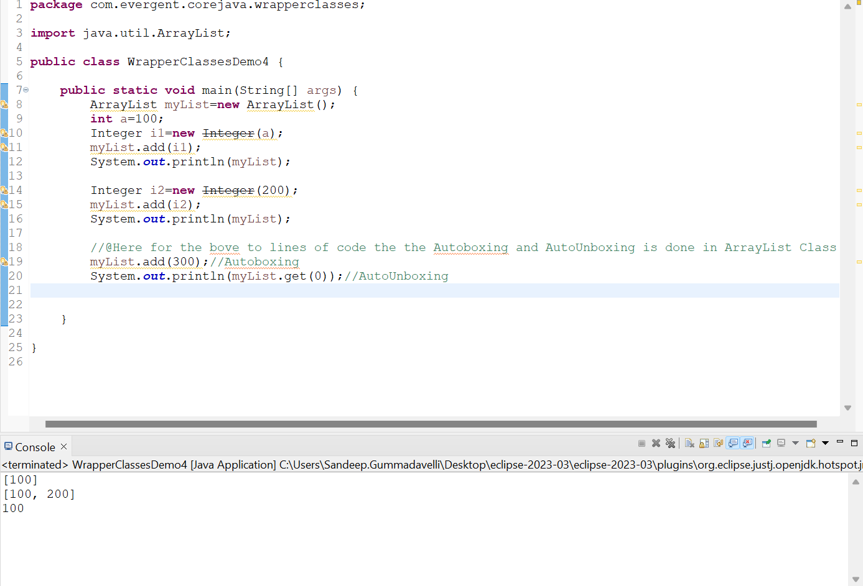

**Program:** WrapperClassesDemo4